  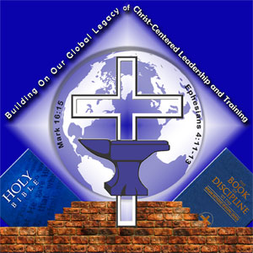
  November 9, 2013
  The Connectional Lay Organization Online
  Bishop William Phillips DeVeaux Sr, Lay Commission Chairman
  Dr. Willie C. Glover, President of the Connectional Lay Organization
  Mrs. Eileen S. Warner, CLO Online Administrator

The Death of Bishop Sarah Francis Taylor Davis, the 126th Elected and Consecrated Bishop of the AME Church
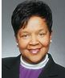
It is with deep regret that we announce the passing of Bishop Sarah Frances Taylor Davis, the 126th Elected and Consecrated Bishop of the African Methodist Episcopal Church.
Updates will follow as soon as available.
Please keep Episcopal Supervisor Claytie Davis and family in your prayers.
Message received from retired Bishop Carolyn Tyler Guidry
Reprinted with permission from The Christian Recorder Online

