  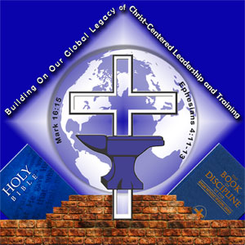
  October 8, 2013
  The Connectional Lay Organization Online
  Bishop William Phillips DeVeaux Sr, Lay Commission Chairman
  Dr. Willie C. Glover, President of the Connectional Lay Organization
  Mrs. Eileen S. Warner, CLO Online Administrator

Bishop Richard Norris Launches Ambitious Documentary Marking 150th Anniversary of the South Carolina Annual Conference
"Kickstarter Campaign" is underway seeking your contributions to help produce the comprehensive documentary on the role of the AME Church in South Carolina. More than 25 interviews have already been conducted, including US Rep. James Clyburn.

FOR IMMEDIATE RELEASE
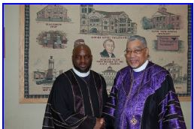
Bishop Norris Commissions New Documentary On The AME Church In South Carolina

Oct. 6, 2013 - Bishop Richard Franklin Norris has a bold vision to celebrate the 150th Anniversary of the South Carolina Annual Conference and wants to do something that will forever be remembered. So, he's calling on Rev. Mark Kelly Tyler, Ph.D., pastor of Mother Bethel AME Church in Philadelphia to produce a powerful documentary to capture the witness of the AME Church in the Palmetto State. Providing the seed money to conduct over 25 interviews and produce a short "teaser" of the actual film, Bishop Norris and Dr. Tyler are now banking on the good people of the AME Church and beyond to 'kickstart' the documentary.
"Kickstarter" is a new, online platform for giving to projects that people find worthwhile. You can give any amount of money you wish toward the goal of $40,000. Depending on the level of giving, there are also perks including being named in the credits of the documentary. If the project reaches its goal of $40,000 by the deadline, the documentary will be funded. If not, all donations are automatically returned to the donors. The deadline is Sunday, November 17th. "The third Sunday in November is traditionally associated with the 'Walkout' from St. George's Methodist Church," says Rev. Mark Kelly Tyler. "What a great way to celebrate our independence, and the 150th Anniversary of the SC Annual Conference."
Dr. Tyler also produced the documentary on Bishop Richard Allen and "Echoes From The General Conference" that was shown repeatedly on the jumbo-tron during the most recent General Conference in Nashville. The new film is entitled "The AME Movement : African Methodism in South Carolina," and will tell in gripping detail the life of African Methodism in South Carolina during the Antebellum, the Reconstruction, resistance to Jim Crow, leadership in the Civil Rights Movement and beyond. It will also tell the proud story of its prized institutions such as Mother Emmanuel and Allen University. Time will also be devoted to the rise of preaching women in the ranks of clergy, the Women's Missionary Society, the Lay Organization, the Sons of Allen, and the Young People's Department.
You can view the teaser and make your contribution by logging onto the documentary's Kickstarter page (http://www.kickstarter.com/projects/693272082/the-ame-mov...). If that's too much to remember, you can also send an email to scamechurch@gmail.com and the Kickstarter Campaign page link will be sent back to you in an email. So far, almost $2,000 has been pledged! Be sure to share this information with your family and friends. You might even consider holding a fund raising Sunday at your church. For more information or questions about the new documentary "The AME Movement - African Methodism in South Carolina" email Dr. Tyler at markkellytyler@gmail.com or call (215) 925-0616.
--
Sent from the Email Address of:
Walter C. Jeffers
Director of Public Relations
Connectional Lay Organization - AME Church
http://www.connectionallay-amec.org

