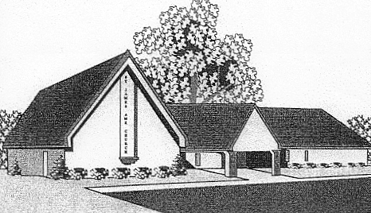
St. James A.M.E. Church

1100 Summit Street
Elgin, Illinois
Rev. Dr. John R. Halbert, Pastor

Revival
“Walking in the Spirit”
Wednesday, May 1 - Friday, May 3, 2013
7:00PM
S i n g i n g P r a i s i n g

Guest Speaker:
Rev. Gary Woods, Heavenly Host Missionary Baptist Church - Flint, MI

Refreshments following services

